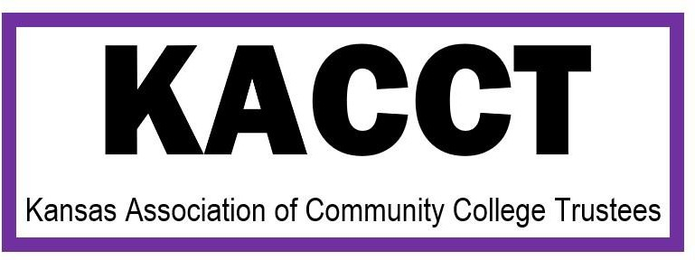

Kansas Community Colleges Support HB 2466

Kansas Community Colleges support additional computer science opportunities for pre-service and in-service teachers. Today, Kansas Community Colleges support various K-12 school districts in providing computer science education. This support varies from dual or concurrent classes to situations where faculty may be shared between the local unified school district (USD) and the local community college. Additionally, our colleges have been hosting boot camps, summer educational experiences, and various STEM activities focusing on robotics, computer science, and cyber-security with a focus on recruiting K-12 pre-service and in-service educators to the educational opportunities. We also offer the array of basic computer science classes that teachers will need to be prepared to teach computer science skills within their classrooms.
Community colleges are in a unique position to serve underrepresented groups and candidates who are interested in computer science who will likely serve in rural areas. We have multiple majority minority serving institutions and institutions located in the rural areas of our state. We are also equipped to quickly help pre-service and in-service teachers gain the computer science skills necessary to help their students. We stand ready and believe this funding would assist teachers in gaining the computer science skills they need to be successful K-12 educators in this field.
Please don’t hesitate to reach out to your local community college or Heather Morgan at the contact information below to learn how community colleges are already striving to help students gain the necessary computer science skills they need to help the Kansas economy and K-12 teachers to prepare their students for the careers available in their communities and the state of Kansas.
For any questions contact: Heather Morgan, Executive Director of the Kansas Association of Community College Trustees, 785-221-2828, hmorgan@kacct.org.

